**Bug-2 Report**

**Group-5**

1. **Failing Test name**

Data cache read Miss Test

1. **Test description (Describe the planned scenario and the expected result)**

read_miss_dcache: A basic read on the data cache was executed, and was expected to get data from level-2 cache.

1. **Failing assertion that helped you identify the bug**

This bug was identified by the scoreboard, since the expected and received values had a mismatch as shown b

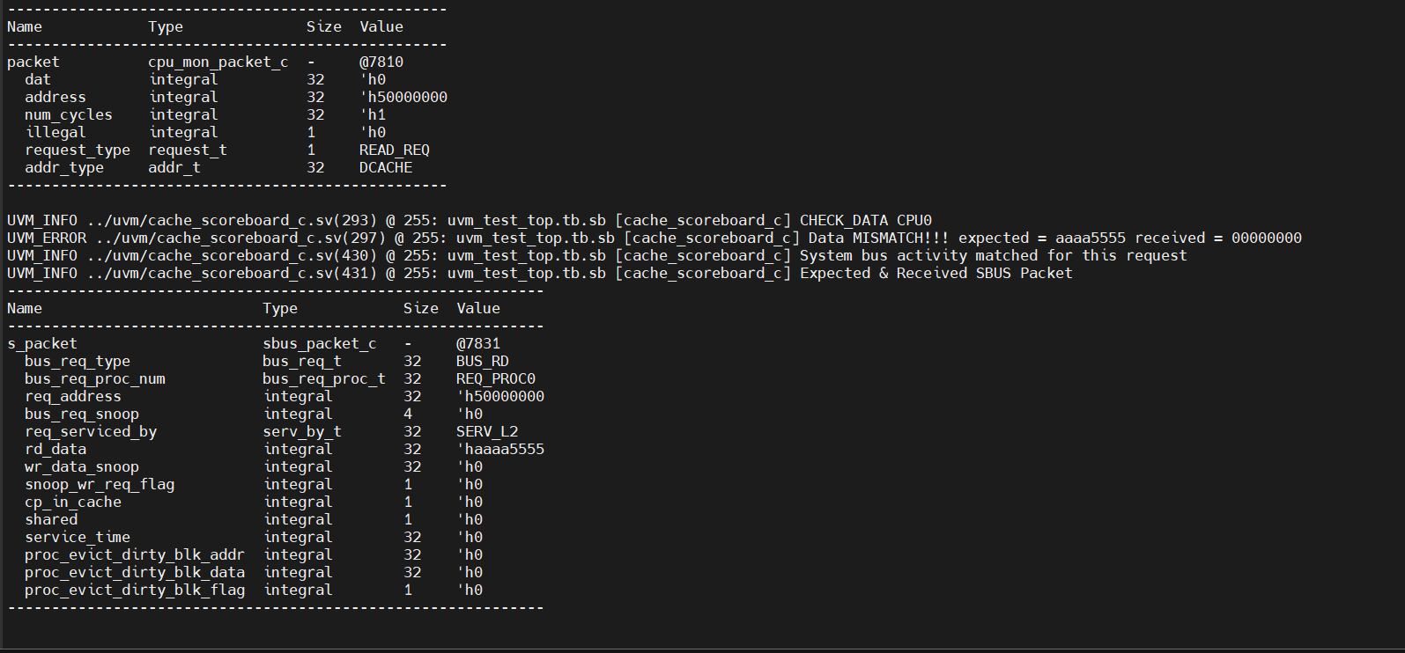

1. **Brief description of diagnosis**

Zero is being received in data_bus_cpu_lv1 even though correct data is present in data_bus_lv1_lv2, so the data is being exchanged wrongly. To correct this, the design files were checked for assignments of data_bus_lv1_lv2 as well as assignments to data_bus_cpu_lv1.

Traced simulation to observe bus_rd signal:

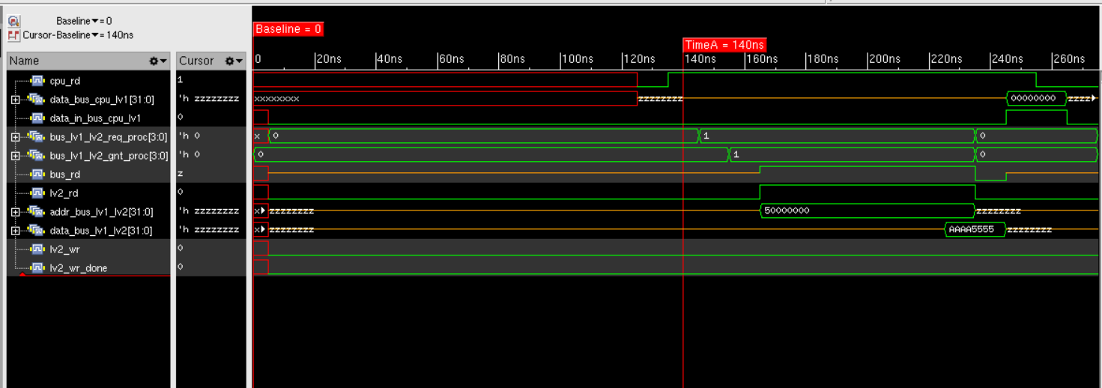

1. **Erroneous RTL file name**

main_func_lv1_dl.sv

1. **Lines of RTL file responsible for the bug (mention the line numbers and lines of the bug)**

170. cache_var[{index_proc, 2’b00}] <= data_bus_lv1_lv2;

1. **Corrected RTL code (only mention the corrections)**

170. cache_var[{index_proc, blk_access_proc}] <= data_bus_lv1_lv2;